12th Annual Buick Pontiac GMC
Tulley Auto Show
Sunday, June 13, 2004
at
Anheuser-Busch Brewery
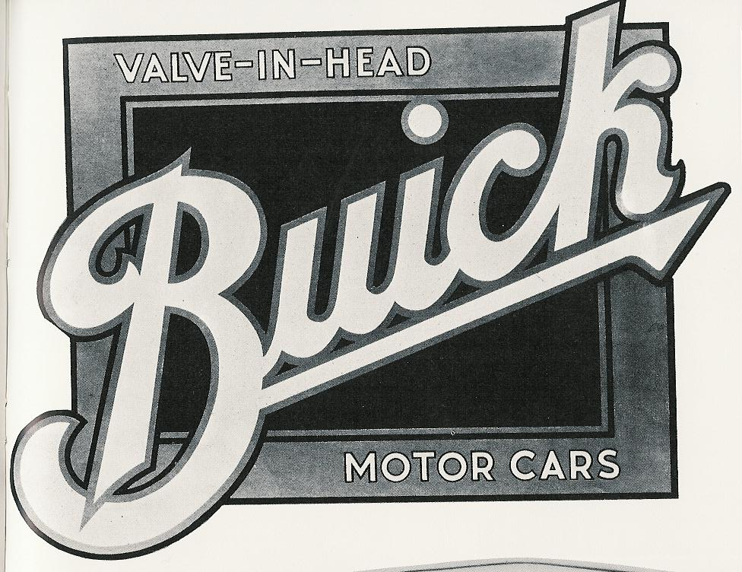
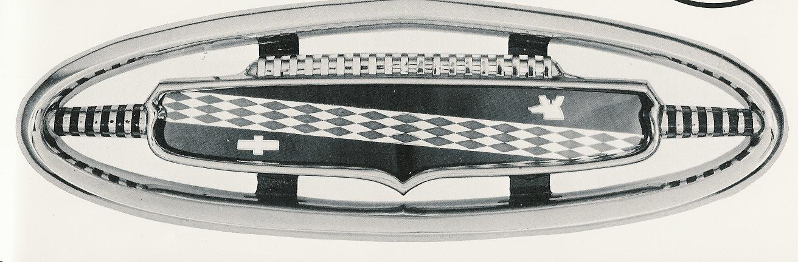
Daniel Webster Highway
Merrimack, NH

Celebrating 47 years


Tulley Buick Pontiac GMC
1957 - 2004

8 am to Noon – Setup and Registration
10 am to Noon - Voting by Participants

2:30 pm – Awards
Food & Beverages Available
Dash Plaque & Goodie Bag for 1st 150 cars
2002 – 10th Tulley Show T-Shirts: $5.00
Vehicle Pre-registration: $ 8.00
Vehicle Registration on show day: $10.00
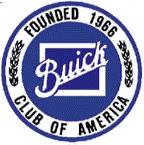


Presented by:
The Minuteman Chapter, Buick Club of America
and
The Nor-Eastern Chapter, Pontiac-Oakland Club International
Sponsored by:
Tulley Buick-Pontiac-GMC-BMW-Mazda-Volkswagen
Nashua, New Hampshire
Tulley Buick Pontiac GMC 2004 Show Pre-Registration Form
Mail by Saturday, May 29, 2004 with $8.00 Pre-registration fee

Name _____________________________________ Phone Number ( ______ ) - _____________________

Address ___________________________________ BCA or POCI Chapter _________________________

City _________________________ State ______ Zip __________ email ____________________________

Car Year ________ Circle Make: Buick / Pontiac / GMC - Model Name _______________ Class _____

Make Checks Payable to: NOR-Eastern Chapter, POCI Send info on Joining: BCA/MMC/POCI/NEC

Mail to: Matt Turner, NOR-Eastern Chapter, POCI, 28 Robin Hood Drive, Nottingham, NH 03290

Classes-Peer Judged
1st, 2nd, and 3rd Place Trophies – ea. class
- 1904-1941 Buick/Pontiac/Oakland
- 1942-1954 Buick/Pontiac
- 1955-1958 Buick/Pontiac
- 1959-1964 Buick/Pontiac
- 1965-1968 Buick/Pontiac
- 1969-1976 Buick/Pontiac
- 1977-present Buick/Pontiac
- 1964-1965 GTO/Skylark GS
- 1966-1967 GTO/Skylark
- 1968-1969 GTO, Judge/Skylark GS
- 1970-2004 GTO, Judge/Skylark GS
- Firebirds, all years
- Trans Am, all years
N. Grand National/Regal T-Type all years
- 1962-1970 Grand Prix/Riviera
- 1971-present Grand Prix/Riviera
- Semi-modified, all years
- Modified, all years
- S-1. Fiero (notchback), all years
S-2. Fiero (fast-back), all years
- Reatta, all years
- GMC, all years
Dealer’s Choice
Best of Show
Longest Distance Driven

Contact info
Buick Club Contact - Andy Seremeth
email – Aseremeth@aol.com
Phone – (603) 880-8685
26 Farley Road, Hollis, NH 03049
Pontiac Club Contact – Matt Turner
email - me.turner@rcn.com
Phone – (603) 679-5738
28 Robin Hood Drive, Nottingham, NH 03290
Tulley Contact – Mark Tulley
email – markt@tulley.com
Phone - (603) 888-0550
Budweiser Brewery Tours - (603) 595-1202
www.budweisertours.com
Directions
Take Route 3 (Everett Turnpike) to Exit 10
East on Industrial Drive
then left on Daniel Webster Highway
Located between Nashua and Manchester, NH

The decision of the show committee shall be final for the classification of vehicles and for combining/eliminating classes, should the need arise. To be eligible for voting, all cars shall be displayed with the hood and trunks open. Trophies should not be displayed with the car to avoid influencing voting.

This show is exclusively for Buick, Pontiac/Oakland, and GMC vehicles. However, you need not be a club member to enter a vehicle.

Cars of other makes and models will have space available for display only.

Pre-registration for vehicles suggested,
but you may register at the show.

Tentative date for 2005 Tulley Show –
Sunday, June 12, 2005

